As of 12 November 2017

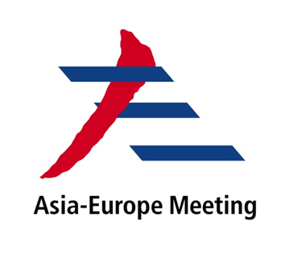
ASEM - 5th ASEM Seminar on Nuclear Safety
Translating Commitments into Actions-Addressing Nuclear Safety Challenges in the 21st Century
28-30 March 2018
China National Convention Centre, Beijing, China

Tentative Programme
28 March 2018 (Tuesday)
08:00 | Registration
09:00 | Opening Ceremony
 | Welcome Remarks by the host country
Speeches: Representatives from Co-Sponsors and previous host countries
High-Level Representative from International Atomic Energy Agency
 | Keynote Speech: officials from relevant Chinese authorities (TBC)
10:00 | Opening Ceremony of China International Nuclear Industry Exhibition (NIC 2018) (1st Floor, China National Convention Centre)
12:00 | Buffet Lunch
14:00 | Session I: New Opportunities and Challenges since Fukushima accident
-Six years after Fukushima accident-latest reflections on lessons learned
-New opportunities and challenges on nuclear safety
-Expectations and needs of emerging nuclear power countries
-Implementation of international nuclear safety instruments (e.g.Convention on
Nuclear Safety )
15:40-16:00 | Coffee Break
16:00 | Session II : Nuclear Safety Oversight
-Legislation & regulation
-Licensing & authorization
-Enforcement & inspection
-Peer review
18:00 | Reception and Dinner

29 March 2018 (Wednesday)
9:00 | Session III: Industry Practice on Nuclear Safety
-Safety measures for new reactors
-Update of safety measures after Fukushima accident
-Harmonization of safety standards and codes
10:40-11:00 | Coffee Break
11:00 |  | Session IV: Capacity Building on Nuclear Safety
-Human resources development
-Fostering a strong safety culture
-Integrated Management System
-Knowledge management
12:40 | Buffet Lunch
14:00 |  | Session V: Emergency Preparedness and Response
-National emergency response measures
-International and regional coordination
-Public communication
-Synergy between nuclear safety and security
15:40-16:00 |  | Coffee Break
16:00 |  | Closing session: Way Forward-follow-up Actions on Nuclear Safety Cooperation within ASEM Framework
30 March 2018 (Thursday)
Whole Day | Optional Field Trip (TBC)

